

Southern Luzon State University
COLLEGE OF ENGINEERING
Computer Engineering Department
Lucban, Quezon

CPE22L: Digital Signal Processing Laboratory

Activity # 2: Signals in MATLAB

PADUADA, Dave Jhared G.

DOP: Sept 6, 2025
DOS: Sept 10, 2025

RATING

Engr. Ralph Monsour Delima
INSTRUCTOR

CPE22L – Digital Signal Processing
Laboratory # 2
- Objectives
  - To define and differentiate different types of signals.
  - To learn how to generate the waveform of continuous time signals and discrete time signals using MATLAB
  - To represent and operate signals on MATLAB

- Introductory Information
Signals are broadly classified into continuous and discrete signals. A continuous signal will be denoted by x(t), in which the variable t can represent any physical quantity. A discrete signal will be denoted x[n], in which the variable n is integer value. In this lab we will learn to represent and operate on signals in MATLAB. The variables t and n are assumed to represent time.

III. Data & Procedures & IV. Data and Results
A. Continuous Time Signals
Problem | Answer | Explanations
%Program P2_1  clf;  t = 0:2*pi; plot(t,sin(t))  title('CT signal plot');  xlabel('t (Seconds)');  ylabel('y(t)');  axis([0 2*pi -1.2 1.2])  Q2.1Run Program P2_1 to generate the continuous time signal and display it. | 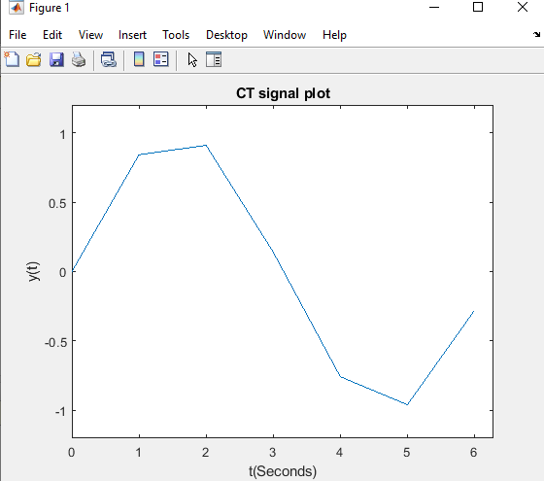 | The graph shows the sine wave over the interval from 0 to 2 π, with appropriate labels & axis limits, making the periodic nature of the signal visible.
Q2.2 Modify the second line in Program P2_1 to  - (a) t = 0:0.2:2*pi; plot(t,sin(t)) | 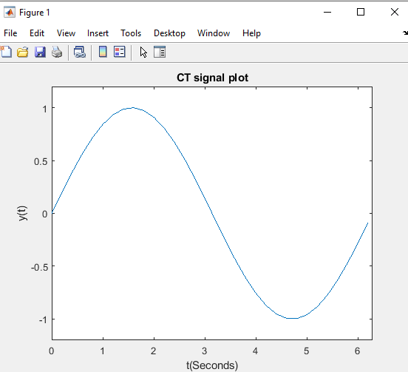 | When the step size is changed to 0.2, the plot looks smoother compared to the original because more points are taken to represent the sine function, giving a better approximation of the continuous signal.
- (b) t = 0:0.02:2*pi; plot(t,sin(t)). | 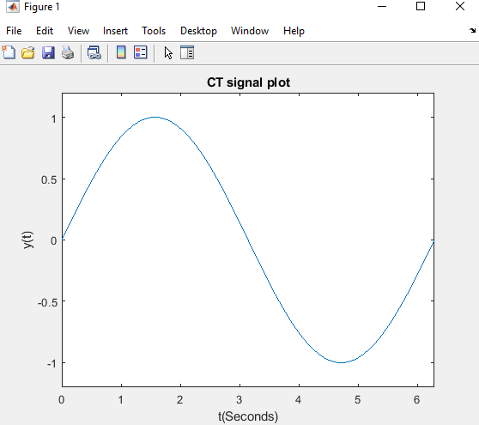 | When the step size is further reduced to 0.02, the plot becomes even smoother and appears almost identical to a true continuous sine wave. This happens because as the step size approaches zero, the sampling points gets denser, and the plot more accurately represents the continuous-time signal.
Q2.3 Modify the second line in Program P2_1 to 2  - t = 0:0.2:2*pi; plot(t,sin(t),t,sin(2*t)) to generate two plots on the same axis. | 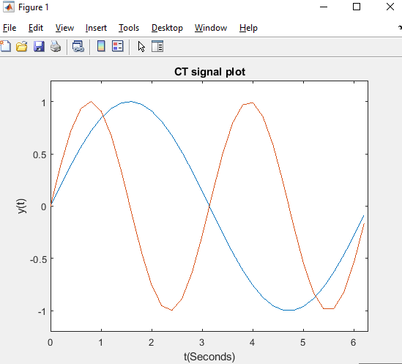 | The code generates two plots on the same axis: one for sin(t) and another for 2sin(t), allowing us to compare their frequencies directly.
Q2.4 a. Modify the second line in Program P2_1 to  t = 0:0.2:2*pi; plot(t,sin(t),'.') to produce a plot without connecting the points. | 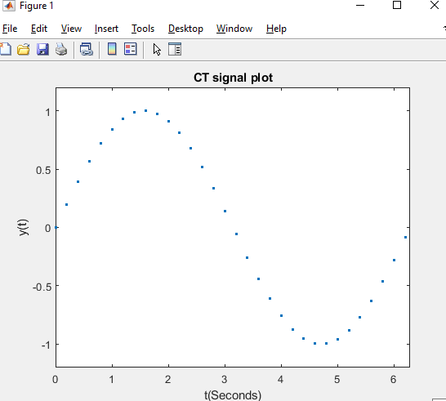 | When the code is modified, the graph shows only the sampled points as dots without connecting lines, making the sine wave appear as a dotted signal.
Q24.b Modify the second line in Program P2_1 to t = 0:0.2:2*pi; plot(t,sin(t),'r.'). What does ‘r’ do? | 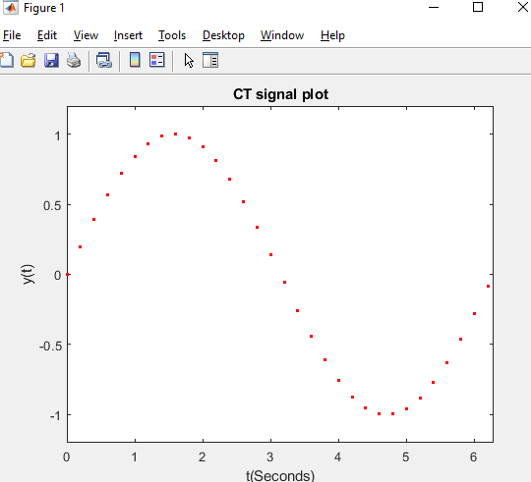 | When using plot(t,sin(t)m’r.’), the ‘r’ specifies the color red, so the dotted points are displayed in red instead of the default blue.
Q2.5 Run Program P2_2 to generate common continuous time signals with frequency of 2 and amplitude of 3.  What is the purpose of the input and subplot command? | 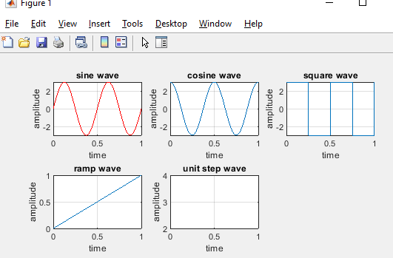 | The input command is used to enter values of frequency and amplitude, making the program flexible. The subplot command is used to display multiple signal plots(sine, cosine, square, ramp, and unit step) within a single figure window for easy comparison.
B. Discrete Time Signals
% Program P2_3  % Generation of a complex exponential sequence  clf;  c = -(1/12)+(pi/6)*i;  K = 2;  n = 0:40;  x = K*exp(c*n);  subplot(2,1,1);  stem(n,real(x));  xlabel(’Time index n’);ylabel(’Amplitude’);  title(’Real part’);  subplot(2,1,2);  stem(n,imag(x));  xlabel(’Time index n’);ylabel(’Amplitude’);  title(’Imaginary part’); | 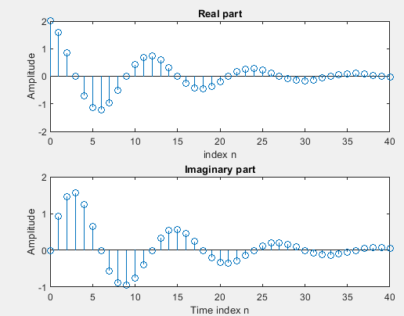 | The output shows two graphs: the real part and the imaginary part of the complex exponential sequence. As n increases to the right, both parts gradually decrease in amplitude because of the negative real component in the exponent, which causes the sequence to decay.
% Program P2_4  % Generation of a real exponential sequence  clf;  n = 0:35;  a = 1.2; K = 0.2;  x = K*a.^+n;  stem(n,x);  xlabel(’Time index n’);ylabel(’Amplitude’); | 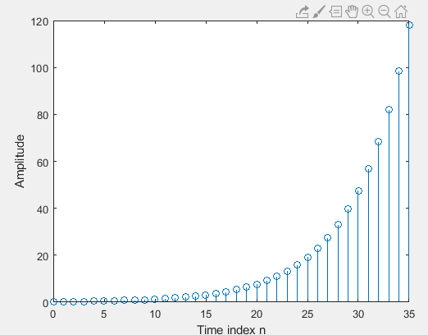 | The graph shows a real exponential sequence where the values start small on the left and grow rapidly as n increases to the right. This happens because the base a = 1.2>1,causing exponential growth.
Answers Q2.6 to Q2.15 | Q2.6: Running Program P2_3 generates a complex exponential sequence, showing two graphs: the real part and the imaginary part. Both parts decay as n increases.  Q2.7: The reap part of parameter c controls the rate of growth or decay. The constant K controls the amplitude of the sequence.  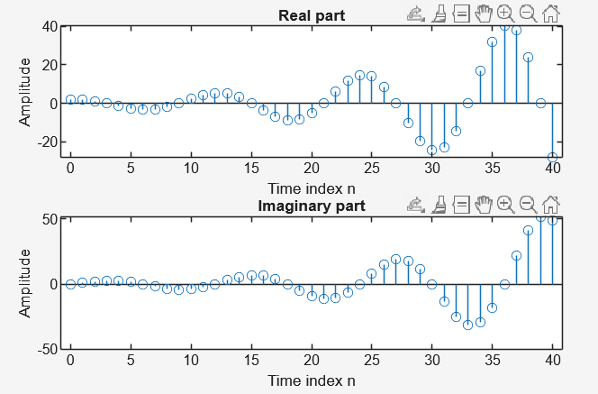  Q2.8: If c = (1/2) + (π/6)i, the sequence will grow instead of decay, since the real part is positive.  Q2.9: The operator real extracts the real part of a complex number, while imag extracts the imaginary part.  Q2.10: The subplot command allows multiple plots to be displayed in the same figure windows for easy comparison.  Q2.11: Running Program P2_4 generates a real exponential sequence that grows as n increases because a = 1.2 > 1  Q2.12: In Program P2_4, the parameter a controls the rate of growth or decay. The constant K controls the amplitude.  Q2.13: The operator ‘^’ is for scalar power, while ‘.^’ is for element-by-element power.  Q2.14: If a < 1, the sequence decays instead of grows. With a = 0.9 and K = 20, the sequence starts large but gradually decreases as n increases.  Q2.15: Using sum(s.*s) computes the energy of the sequence. For Q2.11 (a=1.2, K=0.2), the energy is finite but small since amplitudes start small and grow. For Q2.14(a = 0.9, K = 20), the energy is much larger initially but decays, so the total energy is finite.
Sinusoidal Sequences
% Program P2_5  % Generation of a sinusoidal sequence  n = 0:40;  f = 0.1;  phase = 0;  A = 1.5; arg = 2*pi*f*n - phase;  x = A*cos(arg);  clf; % Clear old graph  stem(n,x); % Plot the generated sequence  axis([0 40 -2 2]);  grid;  title(’Sinusoidal Sequence’);  xlabel(’Time index n’);  ylabel(’Amplitude’); axis; | 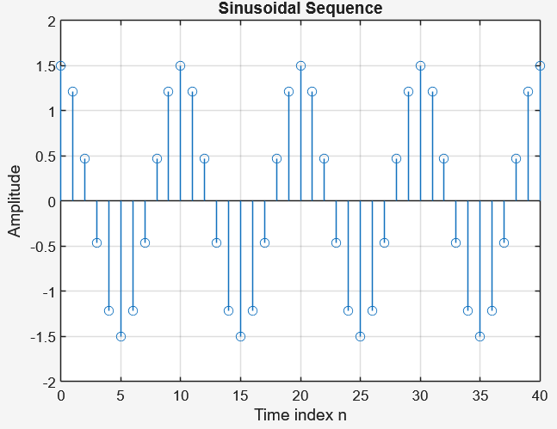
Answers for Program P2_5 | Q2.16: Running Program P2_5 generates a sinusoidal sequence using consine, plotted with discrete points from n = 0 to 40.  Q2.17: The frequency of the sequence is f=0.1 It can be changed by modifying the value of f. The phase parameter controls the phase shift, A controls the amplitude and the period is N = 1/f = 10 samples.  Q2.18: The length of the sequence is 41 samples (from n = 0 to 40). It can be changed by adjusting the range of n.  Q2.19: The axis command sets the range of the x- and y-axes, while the grid command adds grid lines for easier visualization  Q2.20:  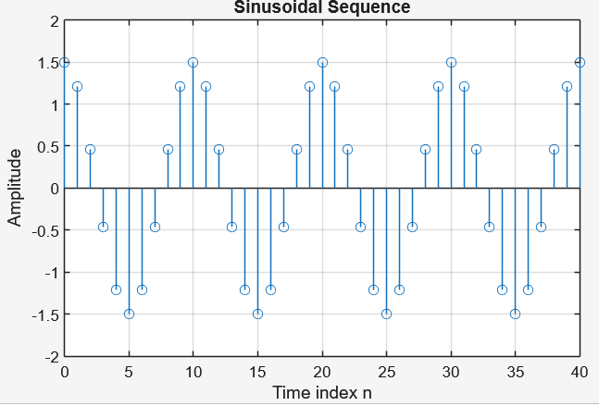  - When the frequency is set to 0.9, the sinusoidal sequence oscillates much faster compared to the original f = 0.1, resulting in a shorter period.  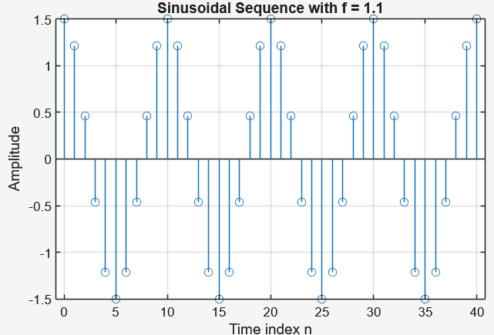  - With frequency is set to 1.1, the sequence shows aliasing and looks distortedcompared to the smooth sinusoid at f = 0.1.  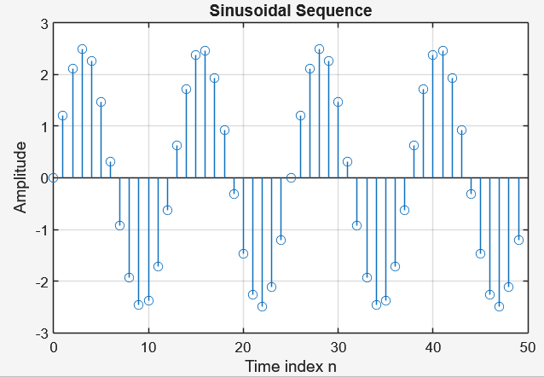  Q2.21: The period of the sinusoidal sequence is 12.5 samples. Since the period must be an integer in discrete-time, the sequence is not strictly periodic, but it repeats approximately every 12 or 13 samples.  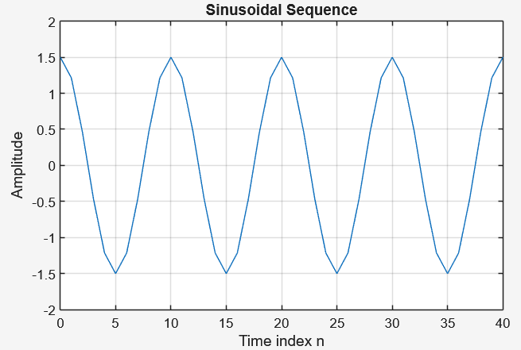  Q2.22: Using the plot instead of stem displays the sinusoidal sequnce as a continuous line, making it look smoother compared to the discrete points in Q2.16  Q2.23: Using stairs connects the data points with horizontal and vertical lines, giving a step-like graph. This looks different from both the discrete dots of stem (Q2.16) and the smooth line of plot (Q2.22).  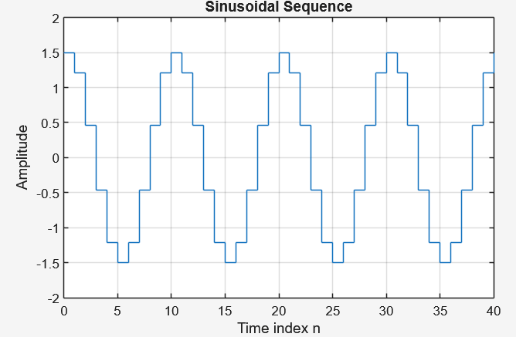
Q2.24 Run Program P2_6 to generate unit sample sequence with 𝒏𝟏=−𝟏𝟎,𝒏𝟐=𝟏𝟎 and 𝒏𝟎=𝟎. | 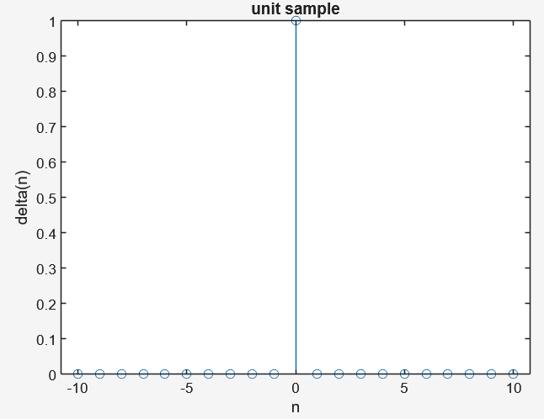 | When Program P2_6 is run with n1 = -10, n2 = 10, and n0 = 0, the output is a unit sample (impulse) sequence. The graph shows a single line (a spike) at the origin n = 0 with value 1, while all other values are 0. This matches the definition of δ(n).
Q2.25 Run Program P2_7 to generate unit sample sequence with 𝒏𝟏 = −𝟏𝟎, 𝒏𝟐 = 𝟏𝟎 and 𝒏𝟎 = 𝟎. | 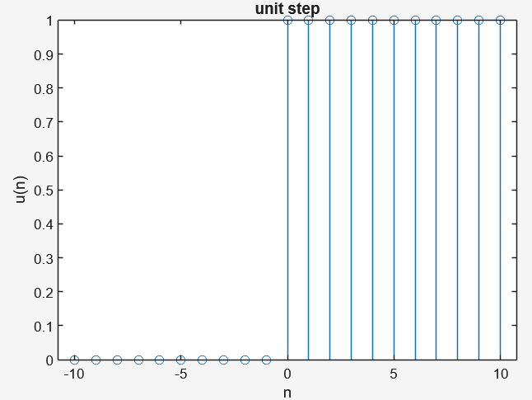 | When Program P2_7 is run with n1 = -10, n2=10, and n0 =0, the output is a unit step sequence. The graph shows that for n≥0, the values are 1(starting at the origin), and for n<0, the values are 0. This matches the definition of the step function u(n).
Operations in Sequence
1. Simple Addition  Q2.26 Run Program P2_8 to add two functions and discuss the result.  Create a sigadd function:  function [y,n] = sigadd(x1,n1,x2,n2)  % y(n) = x1(n) + x2(n)  n = min(min(n1),min(n2)):max(max(n1),max(n2));  y1 = zeros(1,length(n)); y2 = y1;  y1(find((n>=min(n1))&(n<=max(n1))==1))=x1;  y2(find((n>=min(n2))&(n<=max(n2))==1))=x2;  y = y1 + y2;  %Program P2_8  clf;  n1=1:50;  x1=cos(2*pi*0.05*n1);  subplot(3,1,1);  stem(n1,x1);  xlabel('n');ylabel('x1(n)');  title('signal #1');  n2=1:50;  x2=sin(2*pi*0.05*n2);  subplot(3,1,2);  stem(n2,x2);  xlabel('n');ylabel('x2(n)');  title('signal #2');  [y,n] = sigadd(x1,n1,x2,n2)  subplot(3,1,3);  stem(n,y);  xlabel('n');ylabel('y(n)');  title('Signal Addition'); | 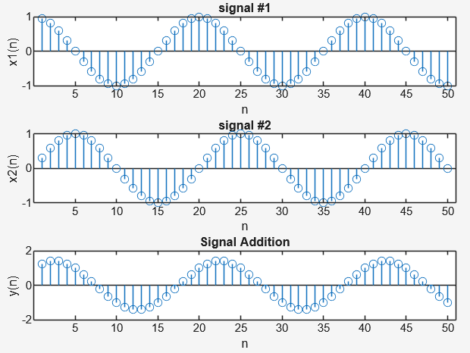 | When Program P2_8 is run, the output displays three graphs. The first graph shows the cosine signal x1(n), the second graph shows the sine signal x2(n), and the third graphs shows their sum y(n) obtained using the sigadd function. The result confirms that signal addition combines the two signals point by point, producing a new sequence that carries the characteristics of both sine and cosine waves.
2. Signal Multiplication  Create a sigmult function:  function [y,n] = sigmult(x1,n1,x2,n2)  % y(n) = x1(n) * x2(n)  n = min(min(n1),min(n2)):max(max(n1),max(n2));  y1 = zeros(1,length(n)); y2 = y1;  y1(find((n>=min(n1))&(n<=max(n1))==1))=x1;  y2(find((n>=min(n2))&(n<=max(n2))==1))=x2;  y = y1 .* y2;  %Program P2_9  clf;  n1=1:50;  x1=cos(2*pi*0.05*n1);  subplot(3,1,1);  stem(n1,x1);  xlabel('n');ylabel('x1(n)');  title('signal #1');  n2=1:50;  x2=sin(2*pi*0.05*n2);  subplot(3,1,2);  stem(n2,x2);  xlabel('n');ylabel('x2(n)');  title('signal #2');  [y,n] = sigmult(x1,n1,x2,n2)  subplot(3,1,3);  stem(n,y);  xlabel('n');ylabel('y(n)');  title('Signal Multiplication');  Q2.27 Run Program P2_9 to multiply two functions and discuss the result. | 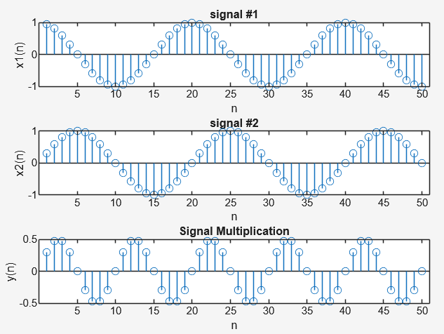 | When Program P2_9 is run, three graphs are displayed. The first graph shows the cosine signal x1(n), the second shows the sine signal x2(n), and the third shows their product y(n) using the sigmult function. The resulting signal demonstrates point-by-point multiplication, where the amplitude of the output varies depending on the values of both signals at each sample, producing a waveform that combines characteristics of both the sine and cosine signals.
3. Shifting  Create a sigshift function:  function [y,n] = sigshift(x,m,n0)  % y(n) = x(n-n0)  n = m+n0; y = x;  %Program P2_10  clf;  m=input('Number of delay(+)/ advance(-) signal: ');  n0=0:7;  x=n0;  subplot(2,1,1);  stem(n0,x);  axis([-10 10 0 10]);  xlabel('n');ylabel('x(n)');  title('Original signal');  [y,n] = sigshift(x,m,n0);  subplot(2,1,2);  stem(n,y);  axis([-10 10 0 10]);  xlabel('n');ylabel('y(n)');  title('Shifted signals');  Q2.28 Run Program P2_10 to delay the original signals by 3 samples. | 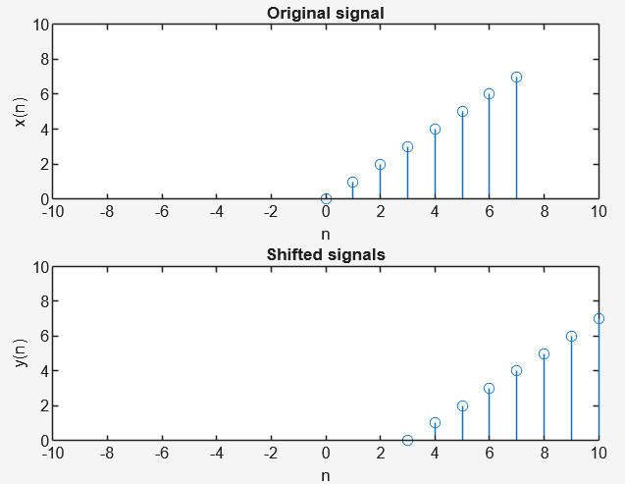 | Wen Program P2_10 is run with a delay of 3 samples, the output shows two graphs. The first graph is the original signal x(n), and the second graph is the delayed signal y(n), where all samples are shifted to the right by 3 units. This represents a time delay.
Q2.29 Modify Program P2_10 to advance the original signals by 7 samples. | 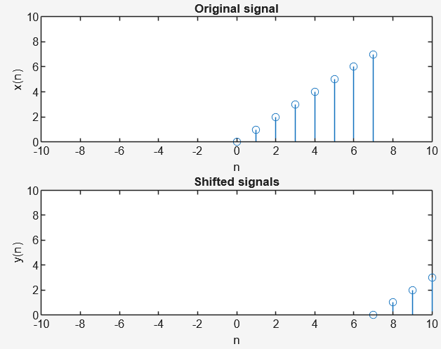 | When the program is modified to advance the signal by 7 samples, the shifted output moves to the left by 7 units. This represents a time advance, showing that the samples occur earlier compared to the original signal.
4. Folding
Create a sigfold function:  function [y,n] = sigfold(x,n)  % y(n) = x(-n)  y = fliplr(x); n= -fliplr(n);  %Program P2_11  clf;  n=0:10;  x=n;  subplot(2,1,1);  stem(n,x);  axis([-11 11 0 11]);  xlabel('n');ylabel('x(n)');  title('Original signal');  [y,n] = sigfold(x,n);  subplot(2,1,2);  stem(n,y);  axis([-11 11 0 11]);  xlabel('n');ylabel('y(n)');  title('Folded signal');  Q2.30 Run Program P2_11 to fold the original signal. | 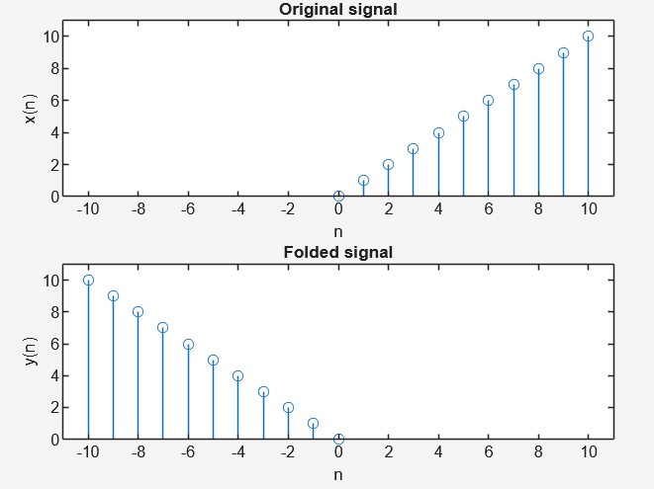 | When Program P2_11 is run, the output shows 2 graphs. The 1st graph is the original signal x(n), and the second is the folded signal y(n), which is flipped around n – 0. This reflects the sequence horizontally, so the order of the samples is reversed.
5. Amplitude Sampling
Create a sigamp function:  function [y,n] = sigamp(x,A,n)  % y(n) = x(un)  n =n; y =A*x;  %Program P2_12  clf;  A=input('Multiply the amplitude of the signal by: ');  n=0:5  x=n  subplot(2,1,1);  stem(n,x);  axis([-10 10 -15 12]);  xlabel('n');ylabel('x(n)');  title('Original signal');  [y,n] = sigamp(x,A,n);  subplot(2,1,2);  stem(n,y);  axis([-10 10 -15 12]);  xlabel('n');ylabel('y(n)');  title('Amplitude Scaling');  Q2.31 Run Program P2_12 with 𝐴 =2 and 𝐴=−3. Compare the results. | 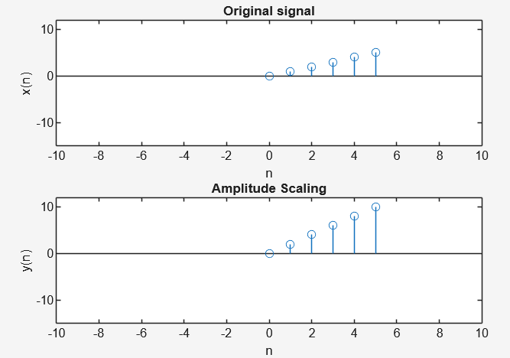
Q2.31 Run Program P2_12 with 𝐴 =2 and 𝐴=−3. Compare the results. | 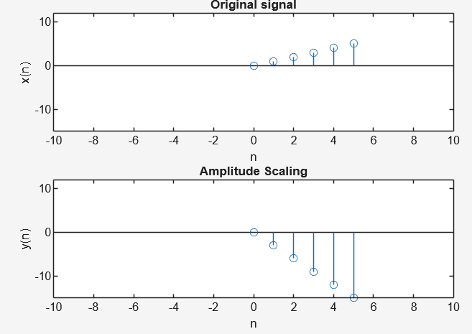 | When Program P2_12 is run with A = 2, the amplitude of the signal doubles, stretching the graph vertically but keeping the same shape and orientation. When A = -3, the amplitude triples and the signal is inverted below the horizontal axis, showing both scaling and sign reversal.

V. Conclusion

In this lab activity, I was able to explore different basic operations on discrete-time signals such as addition, multiplication, shifting, folding, and amplitude scaling using MATLAB. By running the given programs and creating functions, I observed how each operation affects the original signal both mathematically and visually through the plotted graphs. For example, I saw how shifting delays or advances a signal, folding flips it around the origin, and amplitude scaling changes its size or direction. These experiments helped me better understand the fundamental concepts in digital signal processing and how MATLAB can be used as a powerful tool to demonstrate and analyze them.

